Kootenay Lake
School District 8

Occupational Therapy
Fine Motor Development Guide for Teachers
Written by: Ryan Hemming, OTR/L , Crystal Roderick, MOTS , Jennifer Richens, OTAS
Introduction

The purpose of this guide is to provide suggestions for tier II interventions for classroom teachers, in order to assist students with fine motor concerns, which are interfering with the student’s ability to perform basic school tasks. The guide covers several skills, all of which are needed to perform the occupation of being a student. The topics include postural stability, bilateral coordination, hand and arm strength, in-hand manipulation and visual motor integration. This guide also consists of a basic review of the motor milestones of a typically developing child.
The following interventions should be attempted for several weeks before referring a student for an occupational therapy evaluation. In addition, multiple strategies and interventions should be utilized to assist the student with developing age appropriate skills.

Stages of Development
Children require various developmental skills in order for to participate in school as independently as possible. Although all developmental skills are important, occupational therapists are particularly concerned with children’s performance pertaining to eye-hand and arm use, pre-writing, visual-motor and self-help skills. The following pre-requisite skills can help to provide a basic outline of where children should be performing based on their age. It is important to remember that each child develops skills at a different rate and will not necessarily meet each stage within a certain time frame.
- Age 3: Child can hold pencil with first two fingers and thumb (digital pronate grasp). Can copy a circle, imitate a cross, trace a square and scribble on paper. He or she can snip paper and cut a straight line using scissors. The development of a dominant hand is established and child will use non-dominant hand to stabilize paper. Can perform palm-to-finger translation with small objects. Can build a 9 block tower, catch a ball using both hands and can string ½ inch beads. Child may be able to untie a bow, unbutton buttons, and snap and unsnap basic clothing fasteners.
- Age 4: Can demonstrate a tripod grasp with writing utensils. Can copy a cross and imitate a square and X. He or she can color pictures, but will most likely have difficulty staying within the lines. Can build a 6-cube pyramid from imitation and complete a puzzle of 3-5 pieces. Can stack 10 cubes and thread ¼ inch beads. He or she can use scissors to cut out simple shapes, staying on the lines. The child can manage buttons completely, zip most zippers and manage belt buckles or shoes. He or she should be able to dress themselves with minimal supervision. Can recognize right shoe from left.
- Age 5: Preferred hand use is more consistent. Can sew through holes on a lacing card. Is able to cut out a circle. He or she should be able to copy a square or triangle and trace other complex shapes. He or she will begin to color pictures neatly staying in the lines. Can trace letters of the alphabet and begin to copy first name. Can build a 6 cube step and complete a12-15 piece puzzle. Can dress without supervision. He or she begins to tie shoes. Uses a knife for spreading during meal time.
- Age 6: Handwriting should be appropriate for grade. Can cut out complex shapes using scissors. Holds and manipulates paper during cutting. Begins to copy letters of the alphabet.

Case-Smith, J. (2005). Occupational Therapy for Children, (Ed.). St. Louis, MI: Elsevier, Inc.
Pre-Requisite Skills for Handwriting

Handwriting is an essential skill needed for the classroom. In a study by McHale and Cermak (1992), it was determined that elementary school age children spend 31-60% of their school day doing fine motor activities. Of those fine motor tasks, 85% involved the use of both paper and pencil. For this reason, it is important that children develop the pre-requisite skills needed for writing, so they can best participate in classroom tasks and school assignments. The following pages list various pre-requisite skills needed for handwriting and activities that can be incorporated in the classroom to help children develop these important skills.

Case-Smith, J. (2005). Occupational Therapy for Children, (Ed.). St. Louis, MI: Elsevier, Inc.

Ability to Cross Midline
The ability to cross midline involves incorporating the use of both right and left hemispheres of the brain. The two hemispheres work together when a person reaches across the body to complete a task. The ability to cross midline is needed for writing, reading and other self-care tasks.

Classroom Activities:
- Place supplies and writing tools in such a way that the child has to reach across the body to obtain items.  - Create a crawling obstacle course that requires students to climb over, under, and through while on their hands and knees.  - Scooter board activities. Making sure that the child uses both arms in an alternating pattern.  - Toe touches, reaching across to touch the opposite foot.  - Practice tying shoes and working with other clothing fasteners.  - Draw figure 8’s on the white board. | - Play flash light tag. Have children lay down on the floor and dim lights. Have children follow your flashlight beam with theirs.  - Play partner clapping games (i.e. Miss Mary Mac, See See My Playmate).  - Play Simon Says to support crossing midline (i.e. put your right hand on your left hip).  - Draw a large path on the white board and have student trace the path with a toy car or finger. Then have them erase the board using big movements.  - Dot-to-dot worksheets.

Bilateral Coordination
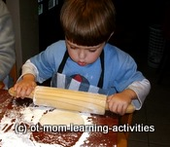
Bilateral coordination is the ability to use both sides of the body simultaneously to complete a functional task. Bilateral coordination can mean using both sides of the body for the same action. It can also occur when each side of the body does a different action. This skill is seen when a child holds a writing utensil in one hand and stabilizes the paper with the other hand. Scissor use and tying one’s shoes are also important tasks that require bilateral coordination. Children should be able to perform complementary two-hand use around the age of 3 years old. The following activities promote the use of bilateral coordination in the classroom.

Classroom Activities:
- Finger painting at desks or on an easel.  - Throwing and catching a big bouncy ball or beach ball. This requires the use of both hands for each action.  - Ripping paper (newspaper, construction paper,etc.)  - String beads or macaroni/pasta.  - Practicing buttons, zippers, snaps, lacing cards, and tying.  - Have one child Blow bubbles and having peers pop bubbles using two hands. | - Staple or punch holes in paper.  - Wring out a sponge and wipe off a table.  - Sharpen pencils or staple papers.  - Open and close jar lids.  - Seal and unseal Ziploc bags.  - Push together or pull apart pop beads.  - Cutting with scissors.  - Gluing objects onto paper for craft activities.  - Drawing with both hands at the same time. Can also use a magna doodle.

Pehoski, C. (2006), Object manipulation in infants and children. In A. Henderson & C. Pehoski (Eds.) Hand function in the child.(pp. 143-160). St.Louis, MI: Mosby-Elsevier.
Body Stability
In order for a child to develop a stable body, he or she must develop postural control. Postural control requires the development of core muscle strength and stability. Once this is mastered, fine motor skills can become more precise and controlled. Activities that incorporate both the upper and lower body are often used achieve good body stability.
Classroom Activities:

- Completing activities while on hands and knees (puzzles, blocks).  - Animal walking (crab, bear, etc.)  - Encourage children to try different positions during play, work, or group time (lying on stomach while resting on elbows or side lying).  - Complete pre-writing shapes while on their tummy.  - Have child sit on a therapy ball rather than a chair.  - Chair and/or wall push-ups.  - Hang up artwork on wall with clothespins | - Completing activities on a vertical surface (writing on the dry erase board, painting on an easel).  - Scooter board activities while lying on stomach.  - Play games such as Twister.  - Yoga positions.  - Cleaning the white board, chalkboard or windows.  - Have children hit a balloon or beach ball back and forth without letting it drop to the ground.  - Pushing or moving classroom furniture or equipment.

Arm and Hand Strength
The small muscles of the hand, as well as the larger muscles in the forearm, are used together when performing fine motor tasks. The muscles of the forearm provide strength and stability, while the smaller intrinsic muscles of our hands allow for more skilled and isolated movement. Prior to writing, children must have well developed arches in the palms of their hands. They must also be able to perform slight sustained wrist extension for writing on horizontal surface. With mature writing and coloring tasks, the thumb, index finger, and middle finger should act as the “skill” fingers by providing movement. The ring and pinky fingers should act as stabilizers. One possible indicator of hand weakness is if a child is unable to maintain an open index finger-thumb web space (an “O”) during fine motor tasks, particularly when using a writing utensil.
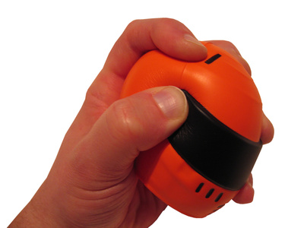
Classroom Activities:
- Use large tweezers to pick up small marshmellows or pom poms.  - Squeeze a stress ball, play dough or putty.  - Use eye droppers to pick up colored water and make designs on coffee filters.  - Use a spray bottle to water plants or to “melt monsters” drawn on the white board or chalk board. Fill the spray bottles with food coloring and make designs in the snow.  - Play on the playground (monkey bars and climbing walls). | - Crumple newspaper in one hand and shoot baskets into the garbage.  - Use pop-beads or pull tubes for warm up activities.  - Squeeze different sized clothespins and place on edge of a container.  - Use a single hole punch to make confetti.  - Play games that incorporate tug-of-war, wheelbarrow walking, or animal walking games to strengthen the arches of the hand.
Saunders D. (2009). Pre-writing skills for children under five. Occupational therapy now, 11(6), 27-28.
Myers, C. (1992). Therapeutic fine motor activities for preschoolers. In J. Case-Smith & C. Pehoski (Eds.), Development of hand skills in the child. (pp.47-59). Rockville, MD: American Occupational Therapy Association, Inc..
In-Hand Manipulation
In-hand manipulation is the ability to move small objects efficiently within one hand. It is one of the most complex skills in the arena of fine motor. Moving coins from palm to finger tips, picking up coins out of a wallet and storing them in palm, unscrewing a lid, adjusting grip on a writing utensil and turning over pencil to erase are all examples of in-hand manipulation. Without sufficient in-hand manipulation a child may be slow, clumsy, or unable to complete certain fine motor activities. They may also use two hands for the manipulation of materials, when using one hand is much more efficient.
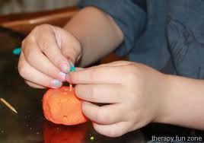
Classroom Activities:
- Cut play dough with scissors or plastic knife, then role play dough into tiny balls.  - Flatten play dough/putty and cut with a pizza cutter.  - Practice manipulating buttons or snaps on shirt.  - Open and close Ziploc bags.  - Lacing activities or lacing shoes.  - Have children open/close various size jars and lids, particularly lids that can be twisted off.  - Moving coins from palm to finger tips and place them in a slot container.  - Dice games. | - Lay out coins or buttons on the table and have a contest to see who can flip the coins over the fastest (without moving coins to the edge of the table).  - Use large tweezers to pick up fruit snacks or small marshmellows.  - Play “Bed Bugs” game or “Operation.”  - String beads, noodles, buttons, and cheerios.  - Remove key from key ring with both hands and place it into a lock with one hand.  - Play Connect Four-have child pick up three pieces at a time and hold them in his or her hand.
Exner, C. (1992).In-hand manipulation skills. In J. Case-Smith & C. Pehoski (Eds.), Development of hand skills in the child. (pp. 35-45). Rockville, MD: American Occupational Therapy Association, Inc.
Grasp
An efficient pencil grasp is an important skill needed for pre-writing. Children typically begin holding a writing utensil with a primitive type grasp. Over time, a more mature grasp should develop. Typically a static tripod grasp emerges around 3 ½ to 4 years old. A dynamic tripod grasp develops around 4-6 years old.
A mature grasp contributes to a child’s legibility and overall success with school related writing assignments. Causes of poor grasp can include: muscle weakness, joint laxity, poor sensory feedback, or lack of experience with writing tools. The following are examples of immature and mature grasps.
Immature grasp:
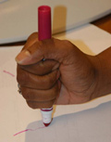
Fisted Palmar Digital Pronate

Mature/Functional grasps:
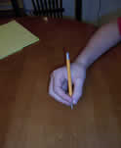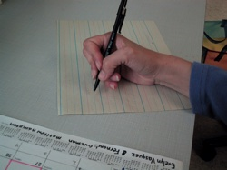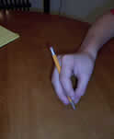
Dynamic Tripod Dynamic Quadrapod Lateral Tripod Adapted Tripod

In general, the most appropriate grasp should exhibit the following characteristics:
- Writing utensil is held in a stable position between the thumb, index, and middle finger
- Ring and little fingers are bent and supported on table.
- An open web space between index finger and thumb
- Wrist is bent upward with forearm resting on table.
- Writing utensil is held about 1-2 cm from the tip
- Movement is produced from the fingers versus the wrist or upper extremity.

Tips for Helping Promote a Mature Grasp
- Have child write on a vertical surface. This enhances wrist extension and proper positioning. Writing on vertical surface can cause wrist flexion, which is impossible for writing.
- Have child hold a pom-pom or cotton ball with ring and pinky finger while using a pincer grasp or while performing pre-writing strokes.
- Use broken chalk or crayons. This naturally supports the use of a mature tripod grasp.

Getting a Grip on Writing (n.d.). Retrieved March 19, 2011 from http://www.getreadyforschool.com/preschool/pencil_grip.htm
Pencil Grasp (n.d.). Retrieved March 19, 2011 from http://www.capitalhealth.ca/especiallyfor/otonhand/finemotor/pencilgrasp.htm
Occupational Therapy- Kids health information.(PDF). Retrieved March 19, 2011 from http://www.childrenfirsttherapeutics.com/pencilgrip.pdf
Amundson, S. (2005). Prewriting and handwriting skills. In J. Case-Smith (Ed.), Occupational therapy for children. (pp. 587-614). St. Louis, MI: Elsevier, Inc.

Hand Dominance
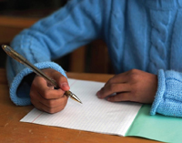
Hand dominance occurs when there is an established preference for a child to use one hand over the other for grasping or manipulating tools. Hand dominance is essential as it supports more efficient fine motor skills that affect the child’s classroom participation. With time and repetition, the child’s dominant hand should become stronger, more skilled and accurate than the non-dominant hand. The non-dominant hand should then assist with activity, but more for support or stability.
Hand dominance appears as early as three or four years old in typically developing children, however it can also develop as late as 8 or 9 years old. It is important that children develop hand dominance before he or she begins to write. Teachers should give students opportunities to develop a hand preference with these strategies and activities:
- Present a writing tool or object at midline and see what hand a child reaches with.
- Observe which hand the child uses spontaneously. For example, which hand he or she uses to rub nose, scratch head, and feed self.
- Encourage child to start and end activity with same hand.
- Evaluate the child’s skills with both hands. Pick the more skilled hand and try to encourage the use of that hand.
- Ask the child which hand feels easier to use.
- Label the appropriate hand with “helper” hand and “working” hand to serve as a reminder for the child.
- Use tongs to pick up small objects, scoop dry beans into containers or hang up pictures with clothespins.
- Have children color on small pieces of paper. This requires that the non dominant hand stabilize the paper.
- Punch holes on cardstock and have child lace through the holes using yarn.
It is important to observe when the switching of hands occurs. If switching occurs midway through an activity it may be due to fatigue. In this case, hand strengthening would be recommended. Poor vision, lack of trunk rotation, or poor posture could also play a role in hand dominance. Always remember to consult the school’s occupational therapist if this is the case.

Sava, D.I. Hand dominance (PDF). Retrieved March 19, 2011 from http://www.supinationwatsu.com/articles/HandDominance.pdf
Hand Dominance. (n.d). Retrieved March 19, 2011 from http://www.capitalhealth.ca/especiallyfor/otonhand/handdominance.htm

Correct Sitting and Paper Position for Writing
Sitting Posture
- While seated at a desk the child should have both feet firmly planted on the floor.
- Table surface should be 2 inches above child’s bent elbows when seated on a chair. Forearms should be able to rest comfortably on the table.
- The table or chair height may need to be adjusted to better fit the child. Foot rests or seat cushions may be used. Consult with your school’s occupational therapist for more information.
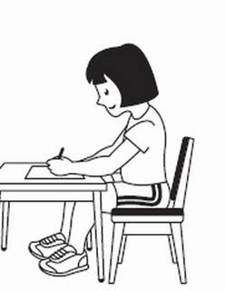
Paper Position
- Paper should be slanted on the desktop so it is turned in the same direction as the writing arm. The opposite hand should assist in steadying the paper.
- Right-handed students should slant the top of their paper approximately 25 to 30 degrees to the left with the paper just right of the child’s midline.
- Left-handed students should slant their paper 30 to 35 degrees to the right and the paper should be placed to the left of the child’s midline.
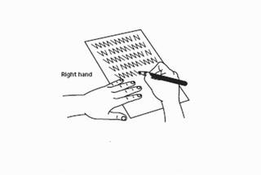

Amundson, S. (2005). Prewriting and handwriting skills. In J. Case-Smith (Ed.), Occupational therapy for children. (pp. 587-614). St. Louis, MI: Elsevier, Inc.
Left Handed Children
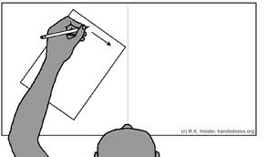

Left-handed children should be encouraged to use their preferred hand. More importantly, they should be taught how to correctly form pre-writing and writing strokes. Without proper training and practice, left-handed children may develop poor and/or inefficient writing skills. The most important factors in left-handed writing are: the position of the writing paper, the position of the arm and wrist, and the grip on the writing instrument. The following are tips for working with left- handed children in the school setting:
- Encourage children to work left-to-right of the paper as they may prefer to do the opposite.
- “Hooked” style of writing should be discouraged and corrected with proper paper positioning.
- Encourage the child to grip his/her pencil 1-1.5 inches away from the point. Place a mark on the pencil to remind child where to put their finger.
- Tilt paper so right arm is at a right angle to bottom edge of paper and top right corner is towards the writer.
- Wrist should be straight when writing and hand should be placed below the writing line.
- Provide left handed scissors for cutting.
- For computer use, place mouse to the left of the keyboard.

Holder, M.K. (2006). Teaching left-handers to write. Retrieved from online website: March 24, 2011 fromhttp://www.handedness.org/action/leftwrite.html

Visual Perception and Integration
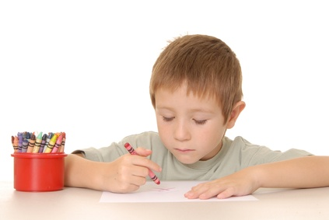
Visual perception is a complex sensory and cognitive process that involves receiving and interpreting visual information. Visual perception allows a child to recognize, recall, discriminate and make meaning of what they see.
Visual motor integration is the ability of the eyes and hands to work together to produce smooth movement. Visual motor integration is loosely referred to as eye-hand coordination. Visual motor integration is especially important in pre-writing and writing. Several studies have found that visual-motor-integration is the best predictor of handwriting ability and performance. Pre-school and kindergarten age children with visual motor deficits may appear clumsy, awkward or unable to perform certain fine motor tasks, thus affecting their quality of work in the school setting.
Classroom Activities:
- Have child color, cut out and put back together handmade puzzles.  - Make letters and numbers out of pipe cleaners, wiki sticks, or play dough.  - Put plastic letters and/or numbers in a plastic bag. Have child reach inside bag and grasp letter. Have child identify the letter before pulling it out to verify if they are correct.  - Make flashcards with letters and numbers that are incorrect (backwards, upside down, missing parts, etc). Have child identify and rewrite number or letter correctly.  - Reinforce visual figures with movement activities. Write letters or draw shapes in the air. You can also turn off lights and use a flash light to draw shapes or letters.  - Simplify child’s surroundings by removing visual clutter.  - Trace, imitate or copy pre-writing strokes from near and far point distances: horizontal line, vertical line, circle, cross, diagonal lines, square, X and triangle.  - String various sized beads. | - Mazes or trail tracing activities.  - Dot to dot activities.  - Play Jacks or Pick Up Sticks.  - Hammering with plastic hammer and nails.  - Lacing board activities.  - Throw bean bags or tennis balls at a target, hoop or basket.  - Paint shapes or letters with a paint brush and paint.  - Have student sort objects according to shape and size.  - Practice imitating block designs.  - Board games such as Candyland and Chutes and Ladders.  - Play games that have to do with directionality and positioning. (Simon says “Stand behind your chair.” “Sit on top of your desk.”  - Draw pre-writing shapes and letters on table top, using shaving cream, pudding or in a tub of sand.  - Catch and throw different size balls from various distances.  - Color inside large, progressing to small shapes, staying inside the lines.

Schneck, C. (2005). Visual perception. In J. Case-Smith(Ed.), Occupational therapy for children. (pp. 412-446). St. Louis, MI: Elsevier, Inc

Fine Motor Coordination
Fine motor control is needed throughout our every day as students dress, write, prepare food, and participate in various classroom activities. Difficulty with using hands and fingers in a coordinated manner may cause frustration and low self image for students comparing themselves to their peers. The following are way to improve hand strength and therefore fine motor coordination.
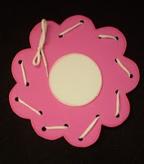
Classroom Activities:

- String beads
- Pop beads
- Pulling caps off markers and pens and replacing them
- Stretching rubber bands
- Using squeeze and spray bottles
- Ripping paper
- Use various size tweezers to pick up small items
- Buttoning
- Twisting twist ties or pipe cleaner
- Playing with small blocks or Lego’s
- Placing coins through a slot
- Open close zip lock bags
- Play with play dough, (find hidden toys inside)
- The game: operation
- The game: operation

Handwriting
Handwriting is an important form of communication and expression for people of all ages both academically and outside the academic world. Because of the fine motor skill and precision required for handwriting it can be a difficult and frustrating skill for children to develop. There are many aspects that take focus in handwriting which can be hard for children to share their attention any may only be able to focus on one rule at a time. The following are areas that children may present as difficulties while writing:
- Line adherence
- Spacing between letters and words
- Letter formation
- Letter reversals
- Organization of page
- Appropriate letter capitalization
- Sizing of letters
- Pencil grasp
- Stabilization of writing hand
- Stabilization of paper with supporting hand
- Ability to copy from near or far distance

This text includes strategies to try with children who struggle within these areas of handwriting. It is important to tackle the issue early so self confidence is not an issue in regards to handwriting.

Line Usage
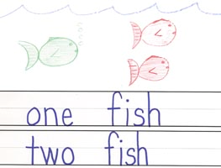
Classroom Activities:

- Draw an individual box for each letter corresponding to the height and width of the letter.
- Have students evaluate their own work, circle where they go outside the lines or poor spacing.
- Use bumpy paper
- Highlight lines on the paper or use stripped paper(blue/white) for a visual prompt to stay within
- “Use pictorial schemes on writing guidelines” (sun, grass, water)
- Call unevenly placed letters are “popcorn letters”
- Isolate the line for the child to write on by having colored paper above and below the line or cut a line in a folder the size of the line and move it up to the next line as the child progresses through the paper
- Dots for beginning and end points for each letter
- Practice small versus tall letters
- Match lined paper with the student’s writing size on unlined paper and work towards age appropriate paper

Age appropriate paper: kindergarten: unlined 1” paper
Grade 1: 1-3/8” lined paper
Grade 2: 3/8-1/4” paper
Grade 3: ¼- standerd notebook paper
Grade 4 and up: standard- college ruled (Dangel& Landreman, p 25).
Spacing
Many students have a difficulty with spacing correctly whether it is writing letters on top of one another, words having no separation from one word to the next, or a variety of other difficulties. A student’s ability to space correctly is a visual perceptual skill that requires thought, planning, and doing. Planning is required before the end of a line is met to decide if adequate room is available to fit the next word. In other instances a student may be able to plan sufficiently but motor skill of actually doing may be missing. If a student is having difficulty with spacing make sure their vision has recently been checked.
Classroom Activities:

Letters
- Begin a “no touching rule” for all letters
- Place a dot between each letter
- Use graph paper and allow 1 letter per box (or notebook paper sideways)
- Box writing
Paper
- Have student skip a line in their writing
- Number lines on paper
- Use stripped paper (every other line blue)
- Color code margins
- Copy the spaces
Words
- Place a dash between words
- Use index finger on non-dominant hand or popsicle stick as a continual visual spacer
- Use pieces of adhesive paper that can be removed when the paper is completed.
- Make spaces with a rubber stamp
- Use skittles as spacers
- Teach students that every word has its own bubble

Dangel, A. & Landreman, D. Response to Intervention: An Elementary and Secondary School Guide. (n.d.) Waukegan McCarney, S.B., Wunderlich, K.C., & Bauer, A. (1994). The Teacher’s Resource Guide. Columbia, MO: Hawthorne Educational Services, Inc
Modified from Amundson, S.J. (1998). TRICS for written communication: Techniques for rebuilding and improving children’s school skills. Homer, AK: O.T. KIDS. In Case-Smith, J. (2005). Occupational Therapy for Children, (Ed.). St. Louis, MI: Elsevier, Inc.
Letter Formation and Reversals
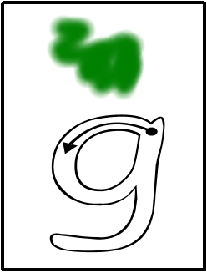
Classroom Activities:

- Connect the dots in letter formation
- (decrease the number of dots depending on the students level)
- Provide arrows to show where to start and the direction of the line (to start from the top rather than the bottom.)
- Play games to teach left/right.
- Have students correct their own work, have them draw arrows to show the correct direction a letter should go.
- Use slant or vertical boards in writing
- Highlight in a magazine all b’s in one color and d’s in another (or m/w’s, p/q’s, etc)
- Form letters with clay
- Have students’ form letters with their own body
- Keep a small alphabet strip on the student’s desk and highlight letters that are struggles or provide arrows for formation of each letter
- Create catchy sayings with the child’s interest to talk about the direction, “d the magic c-way.”
- Make sure there is uniformity in the way formation is being taught at home, school and any other setting.
- Involve multiple senses while writing, verbal, visual, and movement. E.g. use the full arm to write a letter in the sky saying “d, the magic c-way” and provide a picture of a d.
- Trace letters in multiple textures, pudding, sand, on carpet etc.

Solomon, J.W. & O’Brien, J.C. (2006). Pediatric Skills for Occupational Therapy Assistants, (2nd ed.). St. Louis, MI: Mosby, Inc.

Copying from the Board
Classroom Activities:
- Increase print size
- Have students directly face whiteboard
- Teach to copy multiple words at a time or letters at a time (according to appropriateness)
- Provide student with a copy of information to have at the desk to copy from a near point when possible.
- Highlight what is important to copy,
- use dark colors on white surfaces (black and blue)
- Decrease visual clutter around board and desk
- Allow student to copy a peers notes from the board
- Reduce any glare
- Allow for more speed
- Reduce extra input, such as noise and movement
- Allow rests for attention, eyes, and hands

Dangel, A. & Landreman, D. Response to Intervention: An Elementary and Secondary School Guide. (n.d.) Waukegan CUSD 60 Occupational and Physical Therapy Department.
McCarney, S.B., Wunderlich, K.C., & Bauer, A. (1994). The Teacher’s Resource Guide. Columbia, MO: Hawthorne Educational Services, Inc
Modified from Amundson, S.J. (1998). TRICS for written communication: Techniques for rebuilding and improving children’s school skills. Homer, AK: O.T. KIDS. In Case-Smith, J. (2005). Occupational Therapy for Children, (Ed.). St. Louis, MI: Elsevier, Inc.

Scissor Skills
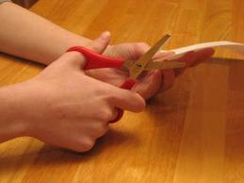
Scissor mastery is an important fine motor skill that typically develops in preschool. Scissor skills are needed for many functional activities of daily living and are required for school related tasks. Cutting with scissors typically requires several pre-requisite skills such as at attention to task, sufficient grasp and release, good in-hand manipulation, eye-hand-arm coordination, shoulder, elbow, and wrist stability, bilateral coordination and appropriate sensory feedback. The development of scissor skills typically follows a sequence. In general, the child learns to hold scissors, then begins snipping paper and then begins cutting in a straight line. Curved lines, various line lengths, geometric shapes, and various designs develop after the child achieves good scissor control when cutting a straight line.
Classroom Activities:
- Hand strengthening activities such as squirt guns, playdough, putty, and squeeze toys.  - Bilateral activities such as sewing cards, tearing paper or stringing beads.  - Roll play dough into a long tube and have child cut tube into small pieces.  - Have child cut out paper snips and use paper snips to create an art project.  - Place glue on the line to be cut and let dry. Then allow child to cut line. This helps the child to slow down when cutting. | - Graduate thickness of paper. Start with cardstock, progress to construction paper, then paper bags and then traditional paper.  - Cut using various media once the child can stabilize the paper efficiently: aluminum foil, wax paper, straws, yarn, sandpaper or fabric.  - Slowly decrease the width of the cutting lines as the child’s eye-hand coordination improves.

Scissor Grasp
When using regular scissors, the correct grasp is thumb in the top loop, with the middle finger in the bottom loop. The index finger is left out and used to provide stability when cutting. The ring and pinky finger are curled towards the palm. In addition, the child should hold the paper to be cut with his/her non-dominant hand with the thumbs of both hands up (pointing toward the ceiling). Remember thumbs up!!! Left- handed students should be provided with left-handed scissors whenever possible. If the elbow of the dominant hand is seems to stick out when cutting, this typically means the non-dominant hand should be re-positioned. It may help to have the child rest his/her elbow of the dominant hand on the table. In addition, teach your student to cut counter-clockwise and reposition the non-dominant hand as needed.

Schneck, C. & Battaglia, C. (1992).Developing scissor skills in young children. In J. Case-Smith & C. Pehoski (Eds.), Development of hand skills in the child. (pp. 35-45). Rockville, MD: American Occupational Therapy Association, Inc.
Sava, D.I. Pre-referral intervention for classroom difficulties (PDF). Retrieved April 4, 2011 from http://www.sbac.edu/~werned/DATA/PARENT%20HANDOUTS/Pre-referral%20Interventions%20-%20Deanna%20Iris%20Sava.pdf

References
Case-Smith, J. (Ed.) (2005). Occupational therapy for children (5th ed.) St. Louis, MI: Elsevier, Inc.
Case-Smith, J. & Pehoski, C. (Eds.) (1992). Development of hand skills in the child. Rockville, MD: American Occupational Therapy Association, Inc.
Cleveland, A., Caton, B. & Adler, L. (1997). Activities Unlimited. Elgin, Illinois: Building Blocks.
Dangel, A. & Landreman, D. Response to Intervention: An Elementary and Secondary School Guide. (n.d.) Waukegan CUSD 60 Occupational and Physical Therapy Department.
Getting a Grip on Writing. (n.d.). Retrieved March 19, 2011 from http://www.getreadyforschool.com/preschool/pencil_grip.htm
Hand Dominance. (n.d). Retrieved March 19, 2011 from http://www.capitalhealth.ca/especiallyfor/otonhand/handdominance.htm
Henderson, A. & Pehoski, C. (Eds.) (2006). Hand function in the child: Foundations for remediation. St. Louis, MI: Mosby Elsevier
Holder, M.K. (2006). Teaching left-handers to write. Retrieved March 24, 2011 from http://www.handedness.org/action/leftwrite.html
McCarney, S.B., Wunderlich, K.C., & Bauer, A. (1994). The Teacher’s Resource Guide. Columbia, MO: Hawthorne Educational Services, Inc
Modified from Amundson, S.J. (1998). TRICS for written communication: Techniques for rebuilding and improving children’s school skills. Homer, AK: O.T. KIDS. In Case-Smith, J. (2005). Occupational Therapy for Children, (Ed.). St. Louis, MI: Elsevier, Inc.
Occupational Therapy- Kids health information. (PDF document). Retrieved March 19, 2011 from http://www.childrenfirsttherapeutics.com/pencilgrip.pdf
Pencil Grasp (n.d.). Retrieved March 19, 2011 from http://www.capitalhealth.ca/especiallyfor/otonhand/finemotor/pencilgrasp.htm
Saunders D. (2009). Pre-writing skills for children under five. Occupational therapy now, 11(6), 27-28.
Sava, D.I. Pre-referral intervention for classroom difficulties (PDF document). Retrieved April 4, 2011 from http://www.sbac.edu/~werned/DATA/PARENT%20HANDOUTS/Pre-referral%20Interventions%20-%20Deanna%20Iris%20Sava.pdf
Sava, D.I. Hand dominance (PDF document). Retrieved March 19, 2011 from http://www.supinationwatsu.com/articles/HandDominance.pdf
Solomon, J.W. & O’Brien, J.C. (2006). Pediatric Skills for Occupational Therapy Assistants, (2nd ed.). St. Louis, MI: Mosby, Inc.
Helpful Web Resources
Handwriting
- www.hwtears.com
- www.callirobics.com
- www.firststrokeshandwriting.com
- www.handwritinghelpforkids.com
- www.handwritinginterestgroup.org.uk
- www.ldonline.org
- www.peterson-handwriting.com
- www.dltk-teach.com
- www.hanedness.org
Visual Perception/Motor Integration
- www.ldonline.org
- www.skillsforlearning.net
- www.canchild.ca
- www.edhelper.com/visual_skills.htm
- www.yourtherapysource.com
- http://www.make-the-grade-ot.com
- www.therapyfunzone.com
- http://www.otplan.com
- www.getreadyforschool.com

Helpful Classroom Tools
Pencils
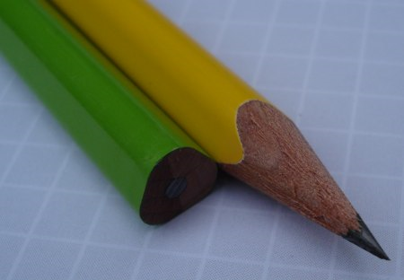  Triangular Pencils: Promotes correct grasping and stability when writing. | 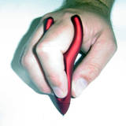  Ergo-sof Pen: Ergonomic design allows for less stress on hand when writing. It also helps to promote an efficient grasp. | 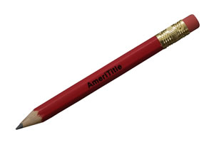  Mini-golf pencil: A small pencil is easier for a child to grip and manipulate.
Grips
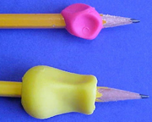  Soft grips: Promote correct finger placement and grasp on writing utensils. | 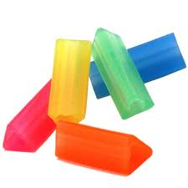  Triangle grips: Provides a comfortable grip that encourages proper finger posture. | 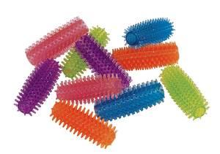  Spiny grips: Provide a comfortable grip and gives extra tactile feedback when writing.
Paper
Raised Line Paper: Paper is raised to provide tactile cues to child to stay within the lines. | Yellow Highlighter Paper: Helps to provide a visual reference to help student develop appropriate letter placement. | Redi-Space Paper: Great for children who have issues with spacing between words and sentences. Can also help support appropriate letter sizing.

Cutting
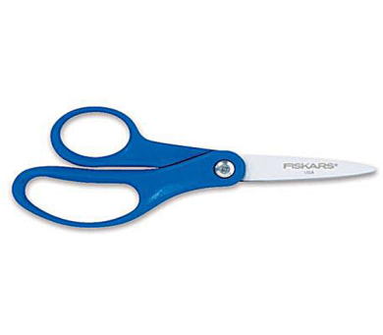  Fiskars: Provides a larger finger loop to support an appropriate cutting grasp. Can be used by left-handed and right-handed students. | 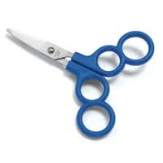  Four Loop Scissors: Help to provide more stability when cutting. | 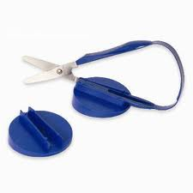  Self-Opening Loop Scissors: Easy to grip and reopen once pressure is released.

Attention
Fidget toys come in many different shapes, textures, and sizes. These can help improve a child’s attention and concentration by keeping their hands busy. They can also provide tactile awareness of the fingers and hands.
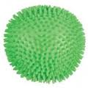 | 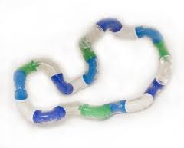 | 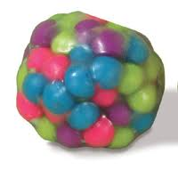

Other Tools
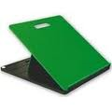  Slant Board: Helps create the optimal positioning for writing. | 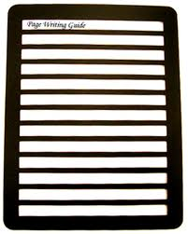  Writing Guide: Helps students to be able to see and write within the lines. | Page Up: Holds paper in correct position for reading and copying from near point reference.

