360 Thinking: Cutting Edge Strategies to Improve Executive Function
Resources Mentioned Throughout the Event

AWW board
https://awwapp.com/b/urqzda8dgilfe/

Pic Collage
https://piccollage.com/login_page

Actively Learn
https://www.activelylearn.com/

Stop and read the room practice
https://tinyurl.com/SWstop

Chrome Extensions
- awesome screenshot
  - https://chrome.google.com/webstore/detail/awesome-screenshot-screen/nlipoenfbbikpbjkfpfillcgkoblgpmj?hl=en
- Lights out for Youtube
  - https://chrome.google.com/webstore/detail/turn-off-the-lights/bfbmjmiodbnnpllbbbfblcplfjjepjdn?hl=en-US
- Ad Blocker Plus
  - https://chrome.google.com/webstore/detail/adblock-plus-free-ad-bloc/cfhdojbkjhnklbpkdaibdccddilifddb

Classroom Tools for Teaching Lessons

Nearpod
https://nearpod.com

Time to Climb
https://nearpod.com/time-to-climb

Insert Learning https://insertlearning.com/

Pear Deck Add On
https://www.peardeck.com/remote-learning

Sarah Ward, M.S., CCC/SLP: Cutting Edge Strategies to Develop Independent Executive Function Skills
Resources Mentioned Throughout the Event

Get Ready * Do * Done Academic Planner
https://efpractice.com/18-frontpage-articles/36-planner

Jamboard - App for “Get Ready - Do - Done” and for VIsually Planning Time and Seeing how Plans Change
https://edu.google.com/products/jamboard/?modal_active=none

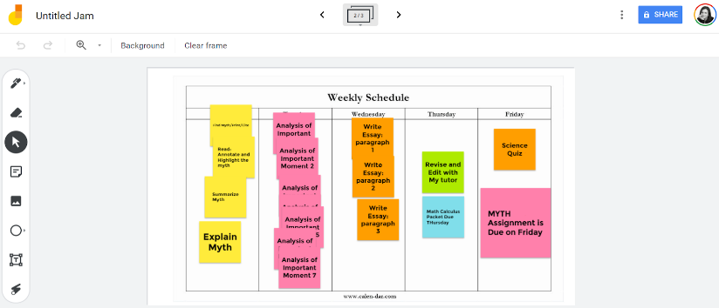

Get-Ready-Do Apps for Virtual Learning
- Google Slides
  - Tutorial: https://www.google.com/search?q=pocketful+of+primary+google+slides&oq=pocketful+of+primary&aqs=chrome.3.0l8.6999j0j7&sourceid=chrome&ie=UTF-8
- Nearpod
  - Tutorial: https://newedtechclassroom.com/how-to-teach-remotely/

- Gynzy Whiteboard
  - Tutorials: https://www.gynzy.com/en/support/getting-started/

- Awesome screenshot
https://chrome.google.com/webstore/detail/awesome-screenshot-screen/nlipoenfbbikpbjkfpfillcgkoblgpmj?hl=en

Video Tutorials for Students to See HOW to complete online tasks
- You Loom
https://www.loom.com/

- Screencastify
https://www.screencastify.com/

- Explain Everything
https://www.google.com/search?q=explain+everything&oq=explain&aqs=chrome.0.0j69i57j46j0l4j69i61.1640j0j4&sourceid=chrome&ie=UTF-8

How is the student doing?

Whiteboard.fi
https://whiteboard.fi/

Kami
https://www.kamiapp.com/

AWW whiteboard
https://awwapp.com/

PollEverywhere.com
- Can be used on phones and devices such as Chromebook

Time Resources:
Ainslee Lab
http://ainsleelabs.com/
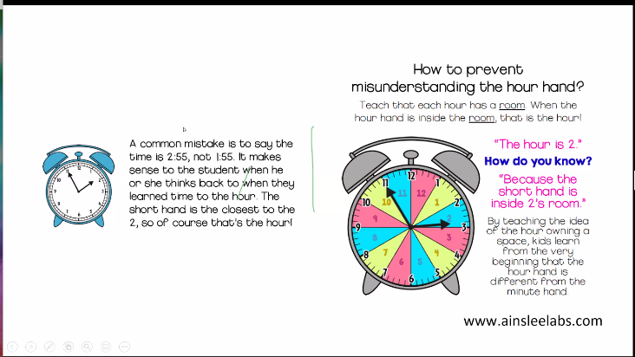

Online Stopwatch
https://www.online-stopwatch.com/large-online-clock/
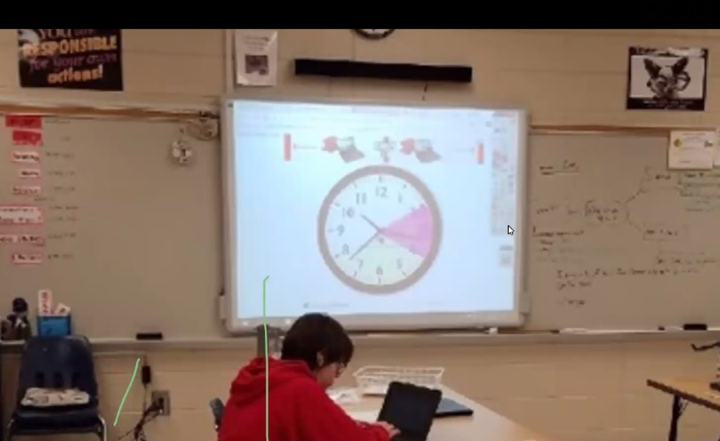

Epic pen
https://epic-pen.com/
- Allows one to draw or mark on any software in real time.

WebPaint
- A Chrome Extension
https://chrome.google.com/webstore/detail/web-paint/emeokgokialpjadjaoeiplmnkjoaegng?hl=en-US

Seeing Hourly Time:
360 Thinking Time Tracker App for ios: https://apps.apple.com/us/app/360-thinking-time-tracker/id1047288370
Large Online Clock https://www.online-stopwatch.com/large-online-clock/
Gynzy white board https://www.gynzy.com/en/

Drawing on a Clock Online:
· Epic Pen Screen Marker App https://epic-pen.com/
· Web Paint Chrome Extension https://chrome.google.com/webstore/detail/web-paint/emeokgokialpjadjaoeiplmnkjoaegng

Time Savers
Use Reader View in your Browser
Mercury Reader to eliminate ads and extraneous information from websites for easier, less distracted reading
Ad Block Plus Chrome extension
Distraction Free Mode for Google Docs Chrome Extension
Forest App https://www.forestapp.cc/
Programs to Control Distraction from Internet Surfing:
• Freedom (Mac and PC)
• PC: www.stayfocusedapp.me
• Chrome: stayfocused add in
• PC: GetColdturkey.com
• Focus Booster (PC and MAC)
• Mac: SelfControl: visitsteve.com/made/selfcontrol/
• Focus, by Brad Jasper (Mac)
• Mac: Macfreedom.com
• Leechblock for firefox
• Rescuetime (Chrome Extension, Mac, Windows, Android)
• Strict Workflow ( Chrome Extension)

Daily/Weekly/Monthly Time:
Google Calendar
Trello: https://trello.com/
Google Keep Chrome Extension
Cognitive Connections Academic, Elementary and Adult Planner: https://www.efpractice.com/shop
Cognitive Connections Digital Academic Planner for iPad or Tablet and use with Notability, Goodnotes, Adobe: https://selz.co/Ny3UXhB-u
Jamboard for Digitally Planning the Steps of a Project: https://jamboard.google.com/
Studyo: integrates with Google Classroom: https://studyo.co

Classroom Screen

Restickable Glue for Long Term Projects
- Turns into a post-it note

Organized Digital Environment

•Check out FENCES (paid) https://www.stardock.com/products/fences/
•How to: https://www.iheartplanners.com/organize-computer-desktop/
•How to Organize Google Classroom https://www.youtube.com/watch?v=sYJErrN0A8k
Good Youtube Resource: How to Organize Your Computer Desktop, Files, & Folders https://youtu.be/lrO-jJf5FI8
•Organize Google Drive Folders and Files:
–https://youtu.be/Vgo0yx945Hw
–https://www.youtube.com/watch?v=dKMhtSKYxfo

Links for Situational Awareness:

Spot the Difference Rooms on YouTube:
https://www.youtube.com/watch?v=0drDdSNO5nk

Random Task Picker:
https://www.online-stopwatch.com/random-name-pickers/cog-machine-name-picker/?r=CjJpMmxHhb

Create a Setting
https://writingexercises.co.uk/create-a-setting.php

Dice Roller App by 7 Pixels
https://apps.apple.com/us/app/dice-3d-7pixels/id1263339902

Magic Mirror Tutorial with zoom backgrounds: Great tutorial: https://youtu.be/WggQwIIoB4Y

Get Ready Do Done Craft Sites

•Babble Dabble DO https://babbledabbledo.com/

•https://kidsactivitiesblog.com/

•PBS Zoom Website: https://mass.pbslearningmedia.org/collection/all-activities/
•https://www.instructables.com/
•http://www.pbs.org/parents/crafts-for-kids/
•Family Fun Magazine: https://funfamilycrafts.com/
•Fun Family Crafts
•Raddish
•GLAD recycling Crafts for Kids
•A Great List of Craft Sites: http://www.kidsites.com/sites-fun/crafts.htm

Assessment:
Using the Bell Curve to see a profile of Strengths and Weaknesses:
https://docs.google.com/presentation/d/1xXl1ltLWaEgoIdTx9JtWD1BIMos2ZIRfG6PSok4Sia0/edit?usp=sharing

