Flexible Seating Options
We are all fully aware of how much more productive we can be when our workplace is comfortable and set up to suit our needs. The same is true for our students. Having flexible seating options in the classroom provides students with choice, empowerment, improved physical health associated with movement, increased engagement/focus and sensory advantages. The sensory advantages include being able to sit/work away from the group to reduce noise/touch/smells/distractions, being able to vary body position as needed, the opportunity to fidget without distracting others, and the opportunity to take advantage of deep pressure touch.
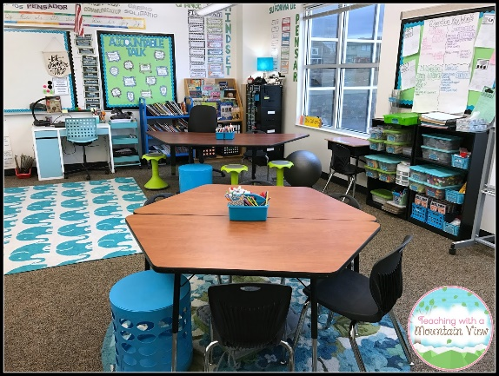
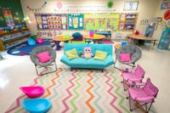
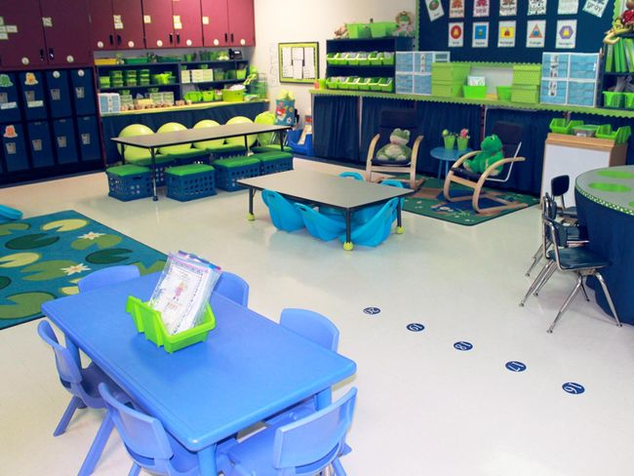

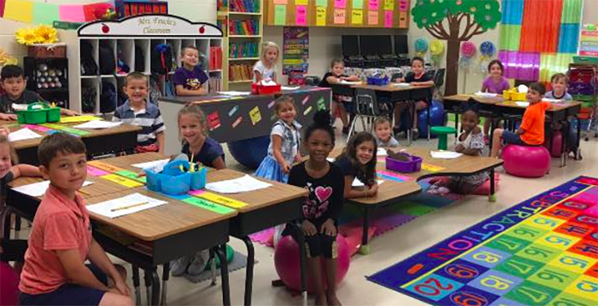
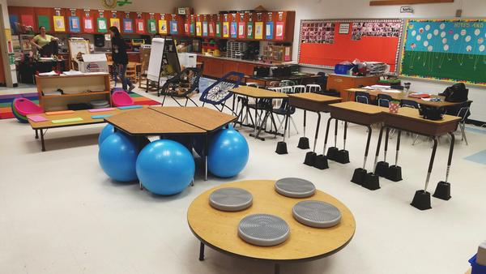

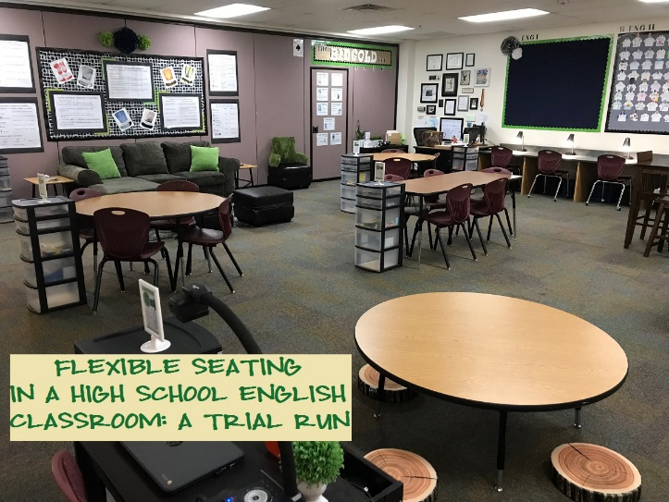
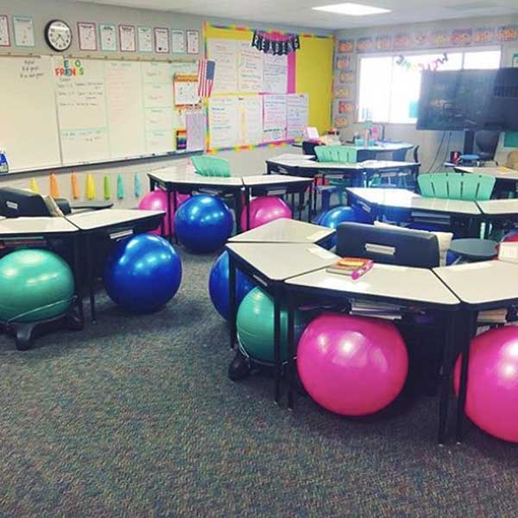
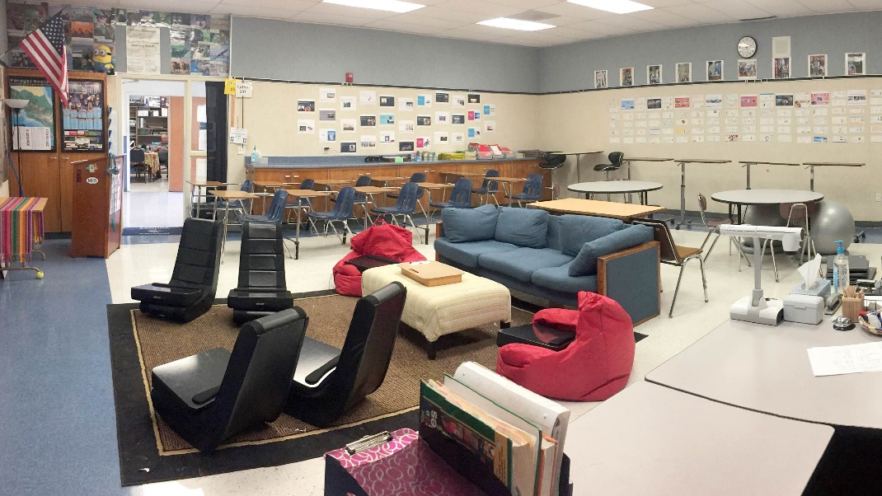
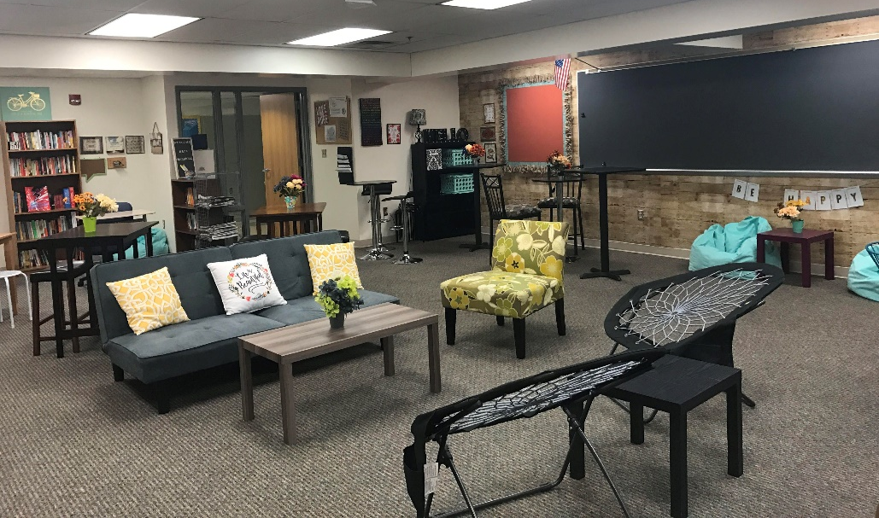

To Get Started
- See what you already have or what you can find in the school that is not being used – i.e. tables that can be lowered or raised, bookshelf that can be used as a stand-up desk, podium, and clipboards.
- Make a plan or a visual of how you would like to organize your classroom or alternatively empty your classroom to get a fresh start.
- Create zones to facilitate traffic flow and work flow.
- Create classroom rules and expectations – See below for a printable

Flexible Seating Options
Hokki Stool  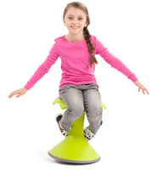  Active sitting option – allows a child to make small movements while sitting. Tapping into the vestibular system and increasing alertness level and attention.  www.steamstudio.ca  www.amazon.ca  $130 | Lap Desk  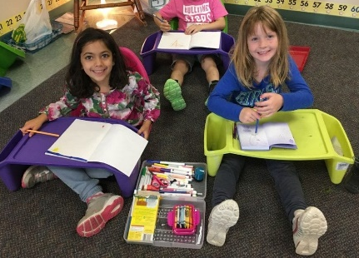  Allows student to sit anywhere in the classroom on the floor/against the wall for deep pressure.  Canada.micheals.com  $9.99 each | Bilibo Seat  (or scoop rocker seat)  Active sitting option – allows a child to make small movements while sitting on the floor. Also helps to provide some deep pressure and delineate seating space. Can be used for independent seatwork with a clipboard or for circle time. www.amazon.ca $50 each  www.wayfair.ca $110 set of 6 | Lying on stomach to work  Provides deep pressure to the stomach area, which is calming and organizing.
Beanbag Chairs  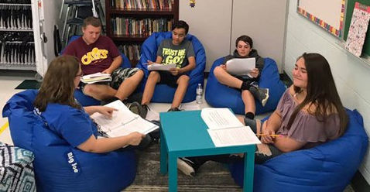  Provides deep pressure and cocooning, which is calming and organizing.  www.walmart.ca  www.schoolspecialty.ca | Lowered Table  Lowering an existing school table is a great way to offer an alternative to sitting at a desk. Students can sit on cushions/carpet squares or kneel. It also promotes collaborative play. | Stand up desk/bookshelf  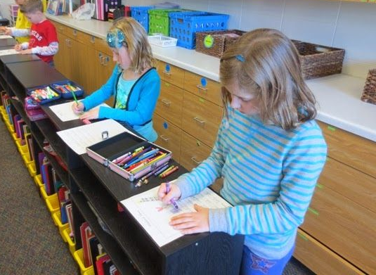  Standing to work is an efficient way to encourage focus and attention. It provides deep pressure in the legs and allows small movements. Use a bookshelf or raise a school desk if possible. | Ball Chairs  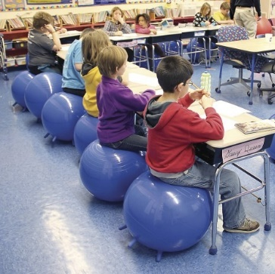  Active sitting option – allows small movements while sitting. Taps into the vestibular system therefore increasing alertness level and attention.  Choose one with stability legs to avoid rolling around. (amazon.ca)  Gaiam Kids Stay-N-Play Children's Inflatable Balance Ball Desk Chair with Stability Legs –
Podium  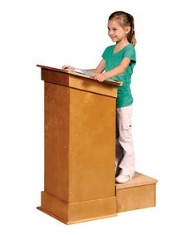  These can sometimes be found in schools and can make a great stand up desk. | Lounge Chair Cushion  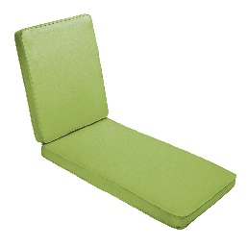  Lounge chair cushions can be used to provide comfort for a child who likes to sit away from the group and lean against the wall for deep pressure. | Rocking Chair  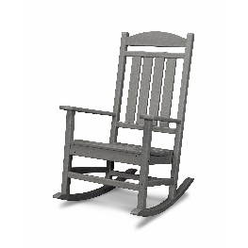  The back and forth rocking motion is very calming. It can be used as a calming/cocoon space when children are overwhelmed, as a defined personal space for carpet time and/or a calming workspace if used with a clipboard.  Tip: put in an “in search of” ad in your school newsletter to parents. | Clothing Hamper with Cushions  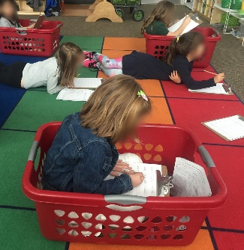  This set up provides great deep pressure and is comforting for children who like tight spaces.
Sit Fit Cushion  (balance cushion)  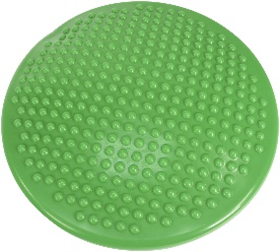  Active sitting option – allows a child to make small movements while sitting. It taps into the vestibular system therefore increasing alertness level and attention.  Abilitations.ca $30 | Egg Shaped Chair  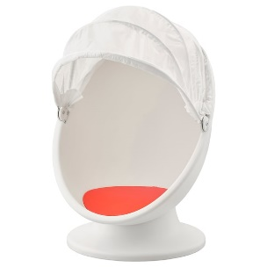  Provides a deep pressure cocoon space.  www.ikea.ca  $90 | Rocker Chair  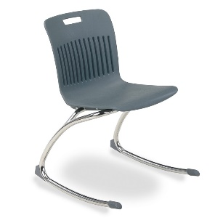  Active sitting option – rocks slightly allowing some contained movements  https://www.worthingtondirect.com/chairs/analogy-series-rocking-chair-by-virco.htm  $74 | Noodle Stack Chair  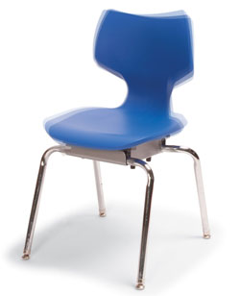  Active sitting option – moves slightly in all directions while providing back support  https://www.worthingtondirect.com/chairs/noodle-stack-chairs-by-smith-system.htm  $122

Flexible Seating Rules and Expectations

Choose a working spot that allows you to do your best work

Use the equipment appropriately

Take care of the classroom equipment

If a spot is not working for you, move so you can be successful.

Flexible seating is a privilege. The teacher can move anyone at any time.

