Fidget Tools
Some students need to move in order to focus their attention and fiddling with an object can be a great way to provide some movement. In order for a fidget tool to be used successfully, it needs to
- Be unnoticeable to others = quiet and in your own bubble
- Be unnoticeable to you = mindless
Use them intermittently - Students can often become desensitized to the sensory benefits of an object, so use it for short periods at times when concentration is most needed and swap between tools over the course of the day.
Clothespin  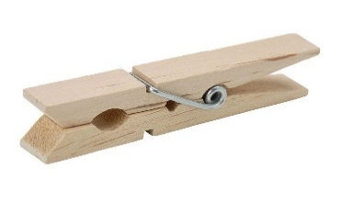 |  | Worry Stones  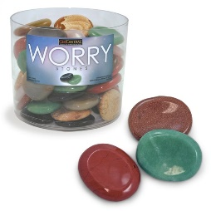 |  | Stress Balls  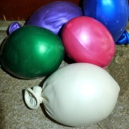  *fill helium quality balloons with flour using a paper funnel |  | Nut and Bolt  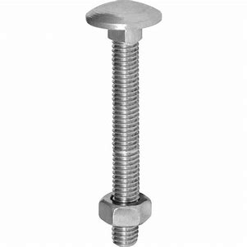
Thinking Putty  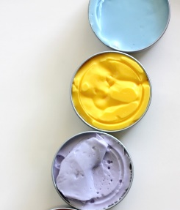 |  | Colour by Numbers  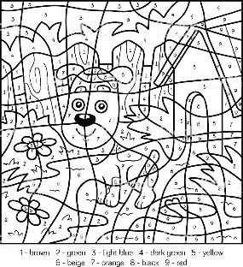 |  | Loop of String  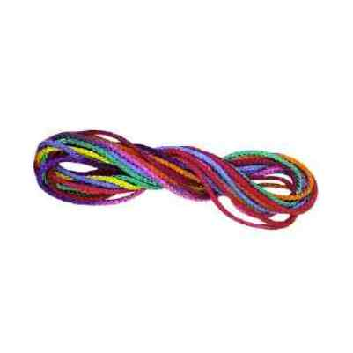 |  | Ziggy Pasta Balls  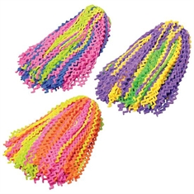  www.flaghouse.ca
Crystal Squeeze Beadball  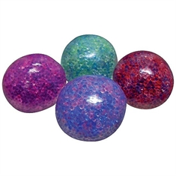  www.flaghouse.ca |  | Desk Buddy  www.flaghouse.ca |  | Feet Fidgets  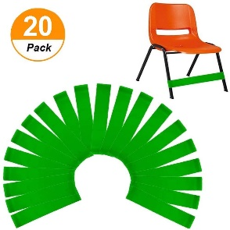  Amazon.ca (Sakolla Chair Fidget Bands for Kids) |  | Feet Fidgets  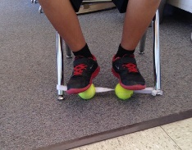  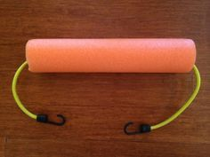
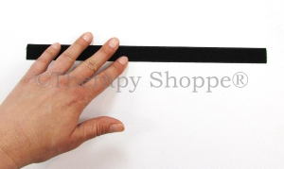  Velcro on underside of desk  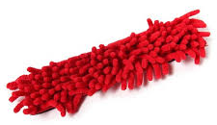  Stick a shaggy material/mop head to the velcro | Begleri –fidget beads  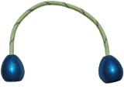  Amazon.ca |  | Edemame Fidget  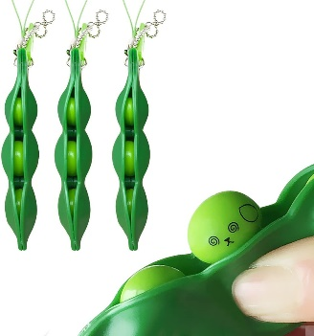  Amazon.ca |  | Marble Fidget  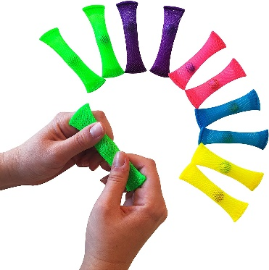  Amazon.ca |  | Fidget for your Digit  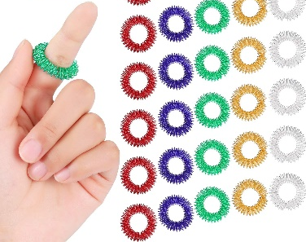  Amazon.ca

Thinking Putty Recipe
Measure ¼ cup of white glue into a bowl
Add food colouring to get your desired colour
Mix up borax solution = 1/4teaspoon of borax to 1/4cup of warm water and stir until thoroughly mixed
Add borax solution to glue and stir – it will come together almost immediately
When it becomes too difficult to stir, take out with hands and knead
Knead until smooth
Store in an airtight container

