Deep Pressure Tools
Deep pressure touch can have a calming and grounding effect on a child’s nervous system. “This is because this type of touch to the body can cause the release of certain brain chemicals (such as dopamine – the “pleasure” neurotransmitter), creates a parasympathetic response in the body (more relaxed, neutral state) and can reduce cortisol levels (the “stress” hormone). Deep pressure touch is also known to help increase our body awareness and over extended periods of time reduce hypersensitivity of the tactile system.” https://occupationaltherapychildren.com.au/deep-pressure/

*Although deep pressure can have an immediate calming effect, our brains can get habituated to that input. As such, it is recommended that a child use a weighted tool for approximately 20-30 minutes at one time. However, it is appropriate to re-use the same tool several time per day.

Classroom Deep Pressure Tool Ideas
Weighted Lap Pad  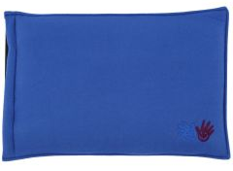  https://funandfunction.com  www.fdmt.ca  http://goodbyenormal.com/multi-sensory-weighted-lap-pad-tutorial-and-giveaway/ | Weighted Shoulder Pad  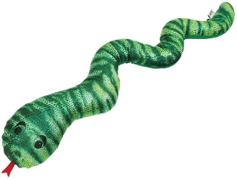  www.fdmt.ca  www.schoolspecialty.ca | Body Sock  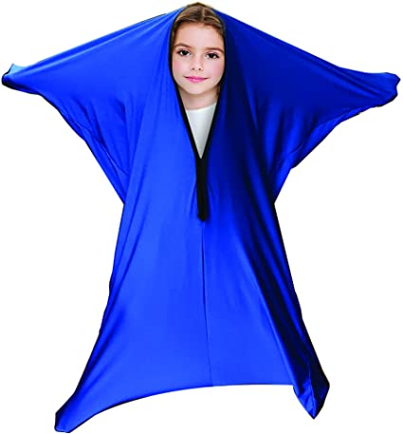  www.amazon.ca  www.fdmt.ca
Massage Roller  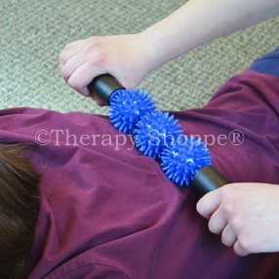  Walmart | Baseball caps/Tuque | Weighted Stuffy  Make your own by filling a stuffy with a bag of pellets/rice/beans.

