Snacks as a Self-Regulating Tool
Have you ever craved certain foods or a warm drink when writing your report cards? Or chewed gum while trying to focus? Have you ever chewed on your pen caps while concentrating or bit your fingernails when nervous? We all have oral sensory habits to some extent. Snacking is generally used for its nutritional benefits but it can also be a very powerful self-regulating tool.

Allowing children to eat throughout the day or encouraging them to eat a snack during specific tasks (i.e. listening to instructions, completing independent seatwork) can be of great benefit.
- It allows some discrete movements
- It is a calming repetitive movement
- It provides deep pressure to the jaw which is organizing, grounding and calming
- The movements of the jaw can muffle surrounding noises
- The different tastes and chewiness levels can also be alerting or calming
- It overall (movement + deep pressure + taste) helps to maintain focus
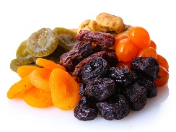
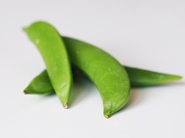
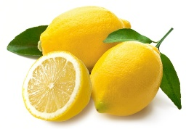
- It overall (movement + deep pressure + taste) helps to self-regulate
Alerting Snack Ideas
Pickles/olives
Citrus fruits; oranges, lemons, grapefruit
Lemonade
Ice-cold water
Popcorn
Rice cakes
Apple slices
Carrot sticks
Snap peas
Sweet and spicy snack mix
Spicy foods such as pepperoni sticks
Celery with cream cheese or peanut butter
Dry cereal
Dried fruit

Chewy
Crunchy
Sour/spicy

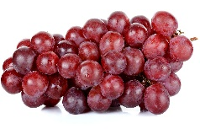
Sweet
Chewy
Resistive sucking
Calming Snack Ideas
Resistive sucking: Smoothie/applesauce through a straw
Bagels
Carrot sticks
Apple slices
Grapes
Dried fruit/fruit leather
Meat jerky
Popcorn
Gum
Chewy granola bars
Soft pretzels
Herbal tea

