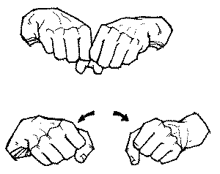Movement Breaks

Sitting still and focusing for long periods of time is very challenging, especially at a young age:

* 5-year-olds: 15 minutes
* 7-year-olds: 25 minutes
* 10-year-olds: 40 minutes

After a certain period of time, the student’s sensory systems start to seek movement in an attempt to maintain alertness (i.e. fidgeting, changing positions, chatting). **By moving, the children are actually trying to stay focused.** However, this can be disruptive to the lesson. Incorporating planned breaks within the daily schedule is an effective way of ‘feeding’ their sensory systems and helping students return to an optimal level of alertness for learning. Breaks are also learning opportunities – body awareness, self-regulation, problem solving, social skills etc.

There are different types of breaks, each with its own purpose. Using a variety of types throughout the school day will keep the students engage and tap into their different needs.

* Brain Break
* Movement Break - Energizing
* Movement Break – Heavy Work (calming and organizing)
* Repetitive Motion Activity (calming)
* Relaxation Break
* Recess Challenges
* High School Suggestions

**Great article**: <https://www.parent.com/how-movement-in-the-classroom-helps-kids-focus/>

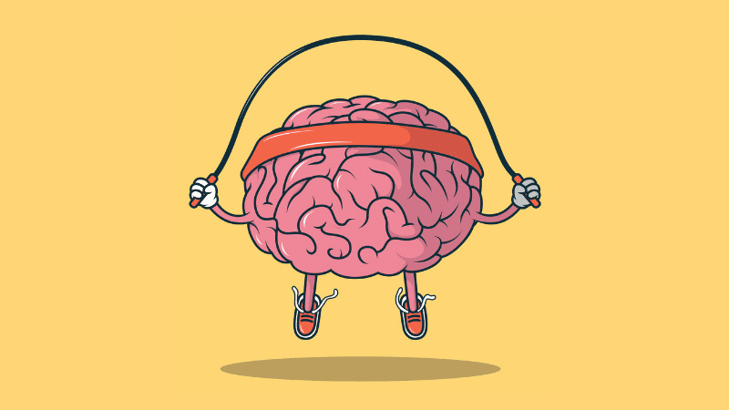**Brain Break**

A brain break is a short period of time when we change up the routine of incoming information. Our brains are wired for novelty. A brain break refreshes our thinking and helps consolidate our learning.

Brain Break Ideas:

**The Junk Bag:** Have a bag of household objects (i.e. a can opener or a pair of shoelaces). Pick any object out of the junk bag and ask students to come up with two ways this object could be reinvented for other uses. They can write or draw their responses. Once students have drawn or written about an invention, they can walk the room for one minute sharing and comparing.

**Squiggle Story:** On a blank sheet of paper or whiteboard, draw one squiggly line and have students copy it for themselves. Then, give students two minutes to stand and draw with their non-dominant hand, turning the line into a picture or design of their choice.

**Symbolic Alphabet:** Sing the alphabet with names of objects rather (animals, fruits etc) than the letters.

**Invisible Pictures:** Have a student draw a picture in the air while their partner guesses what it is. You could give them categories such as foods or places, or other ways to narrow the guessing.

**Would you rather:** Eat round food or square? Live in space or the ocean? Ask questions and let students share.

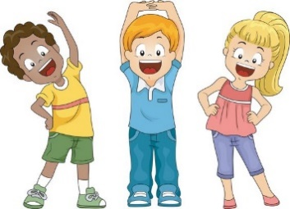

**Movement Break – Energizing**

An energizing movement break is one where children tap into their vestibular system (sense of balance) and is activated when the head is moving. Fast, irregular movements help the body to wake-up and return to an alert state of awareness.

**Important Notes**

*Some children easily get over-stimulated/over-excited by movement and have difficulty returning to a calm state. **Always follow a movement *energizing* break with a *Heavy Work* movement break or a relaxation technique before returning to an academic task.**

**\***Often the child who need to movement break the most is the one who refuses to participate. Give that child the option to run an errand (i.e. like bringing books back to the library or a note for the school secretary in a heavy binder) as this will provide him/her with an opportunity to move but in a different way.

Movement Break - Energizing Ideas

Youtube videos: Go Noodle

Shake Your Sillies Out <https://www.youtube.com/watch?v=NwT5oX_mqS0>

Shake song <https://www.youtube.com/watch?v=7oOaPVq07g8>

Head and Shoulders song

Tip Toe Tag

Statue game**:** Freeze when the person who is “it” turns around

**Movement Break – Heavy Work**

A heavy work movement break taps into the proprioception sense (body awareness). These activities require muscles to stretch and work hard which helps the brain to **regulate and the sensory systems to feel more calm and organized.** 

Heavy Work Movement Break Ideas

**Popcorn Pops:** Have students sit criss-cross on the floor with hands flat on te ground next to their sides. When you say, “Pop!”, they push down on the floor to make their bottom come up off the ground. If you say it once, they pop once. If you say it twice in a row, they do it twice. Etc.

**Movement Break at your Desk**

|  |  |
| --- | --- |
| **Reach Up**  Kids Stretching Images, Stock Photos & Vectors | Shutterstock  **Count to 5 and repeat 3X** | **Shoulder Shrugs**  🤷‍♂️ Man Shrugging Emoji  **Repeat 10X** |
| **Neck Stretches**  After surgery for brain tumours  **Count to 5 and repeat 3X each side** | **Arm Circles**  Seaweed's Oasis Goldylox Commercial  **10 circles in each direction** |
| **Chair Pushups**  Chair Push Up Illustration - Twinkl  **Hold for 5 seconds and repeat 3X** | **Pretend to Sit**  Easy Exercises for Teens (for Teens) - Nemours KidsHealth  **Repeat 5X** |

**Exercise Dice**

Roll 2 dice. The first will help you pick the exercise and the second will tell you how many repetitions to do. (you can also add the two dice together for the number of repetitions)

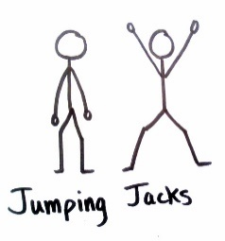

* Jumping Jacks
* Star Jumps

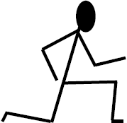

* Lunges
* Chair dips
* Ski Jumps

 Side to side jumps

**Animal Walks Around the Room**

|  |  |
| --- | --- |
| Bear Walk | Crab Walk |
| Frog Jump | Duck Waddle |

**Repetitive Motion Activity (calming)**

Repetitive motions can be very calming and organizing. They can provide a break from focused work will also providing some movement to the body.

**Beading:** have students string beads following a predetermined pattern

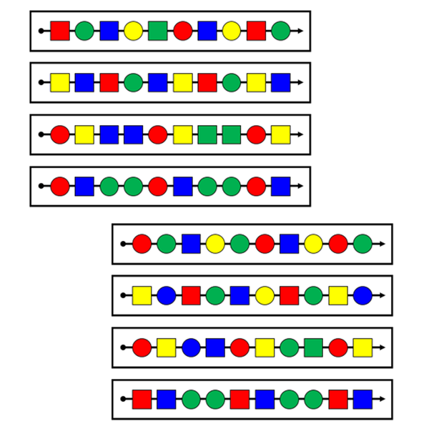

**Sorting Cards:** sort by colour, suit, number, shuffle cards while the teacher is talking

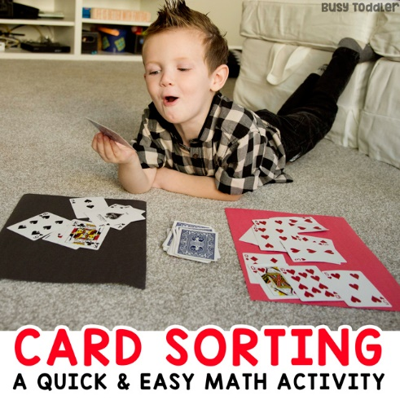

**Colour by Numbers**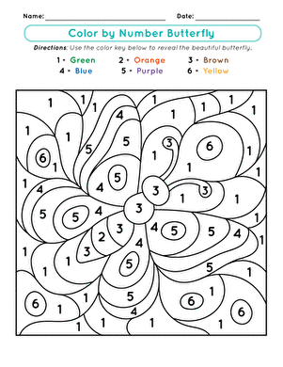

Relaxation Break

Short visualization stories for children <http://www.just-a-minute.org/en/resource_centre/>

Cosmic Kids Yoga videos <https://www.youtube.com/user/CosmicKidsYoga>

Belly Breathe with Elmo <https://www.youtube.com/watch?v=_mZbzDOpylA>

**Colour Breathing:** Visualize colors while focusing on your breathing. Inhale and exhale a red. Have students imagine the colors as swirling and alive with each inhale and exhale. Start with red (alerting colour) and follow the colours of the rainbow to blue (calm colour).

Lazy 8 Breathing:

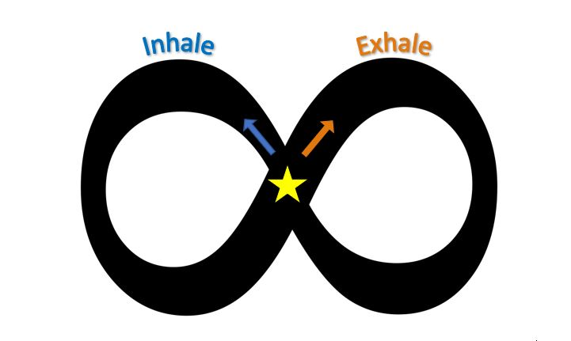Draw a lazy 8 on the board

Have students breath in and out as they trace the lazy 8 in the air

with their finger. Encourage the students to track their finger

movements with their eyes.

**Sound:** The use of sound is very powerful for engaging a calm response. Use rain sticks, bells, chimes, and music. There are many websites that provide music for focus, relaxation, and visualization. Repetitive sounds such as waves can also be used for calming. Practice deep breathing while listening.

***Progressive muscle relaxation***

Progressive muscle relaxation is another effective and widely used strategy for stress relief. It involves a two-step process in which you systematically tense and relax different muscle groups in the body. It also provides deep pressure to your muscles, which is calming and organizing on a sensory level.

* Get comfortable lying on your back or even sitting in your chair
* Take a minute to relax, breathing in and out in slow, deep breaths.
* When you’re relaxed and ready to start, shift your attention to your feet. Take a moment to focus on the way they feel.
* Slowly tense the muscles in your feet as stated below, squeezing as tightly as you can. Hold for a count of 10.
* Relax your feet. Focus on the tension flowing away and the way your feet feels as it becomes limp and loose.
* Stay in this relaxed state for a moment, breathing deeply and slowly.
* Move slowly up through your body.

**Progressive Muscle Relaxation Sequence**

* Point feet
* Pull feet back
* Push legs together
* Push legs and feet into the floor
* Push arms into your sides
* Push hands into the floor or on your chair
* Push shoulders down
* Push shoulders up
* Tuck chin in towards the neck
* “Squint” your entire face

Recess Challenges

Many students do not know what to do during recess or tend to be sedentary and walk around. Encouraging them to be active can help provide their body with the needed physical exercise. Helping them plan activities/games before going out to recess can be helpful. Providing them with physical challenges can also be a good way of encouraging active participation.

|  |  |
| --- | --- |
| Boot Camp  15 donkey kicks  20 ski jumps  20 windmill arms | Cross the monkey bars 5 times |
| Crab walk across the field and back | While hanging from the monkey bars, raise your toes to touch your hands 5 times |
| Do 5 chin ups on the monkey bars | Skip around the school yard |
| Boot Camp  25 jumping jacks  10 push ups  10 sit ups | Run backwards the length of the field and back |
| Jump and complete a 360 in the air 5 times each wa | Roll halfway across the field and back (make sure it is not a wet or muddy day) |
| Complete all the activities on the play structure 2 time | Hang from the monkey bars while slowly singing the alphabet song (sing in your head if you are shy) |
| Boot Camp  10 lunges  50 small arm circles  25 body twists | Boot Camp  50 1-footed hops  50 hops on other foot  50 bird wings arm |
| Tip toe across the field and heel walk back | Walk across the field and back with a bean bag on your head. |
| Shake it  Hands 50 times  Arms 50 times  Right leg 25 times  Left leg 25 times  Whole body 50 times | Run and air write your name using the whole field |
| Boot Camp  High knees 30sec.  Football run 30sec.  Repeat twice | Squat and waddle like a duck across the field, return hopping like a frog (make sure your hands touch the ground with every hop) |
| Boot Camp  Reach for the sky then touch your toes 10 times  Jump as high as possible 20 times  Bicep curls 20 times | Climb up the play structure 5 different ways |
| Push the wall of the school as hard as possible and count 10 Mississippi- repeat 5 times | Do 5 hand stands- count how many seconds your feet can stay in the air |
| Boot Camp  Plank 10sec 3times  Squat 20 times | Swing on a swing 5 minutes |

High school suggestions

Desk top drumming <https://www.youtube.com/watch?v=2-MpzjxEVBU>