Cocoon Space
Having a quiet corner with a variety of calming tools somewhere in the classroom can make a big difference for a child with sensory processing challenges. Often, just knowing that there is a “safe spot” nearby can alleviate anxiety and provide a sense of empowerment. It also teaches children what to do when they are feeling overwhelmed.
To get started:
- Find a corner/space in your classroom that is set away from the main action
- Seclude the area using furniture/tent etc.
- Create a tool box of calming activities and tools see suggestions below
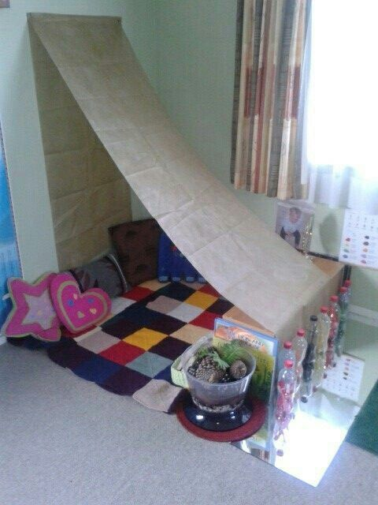
- Create and teach the rules on how and when to use the cocoon space see suggestion below
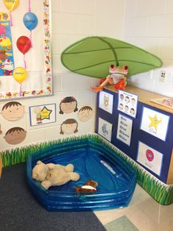
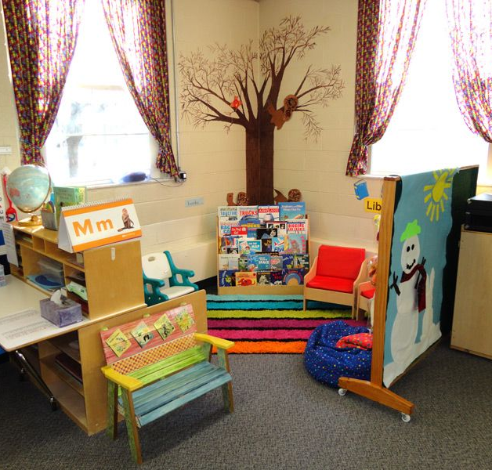

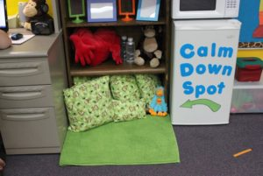
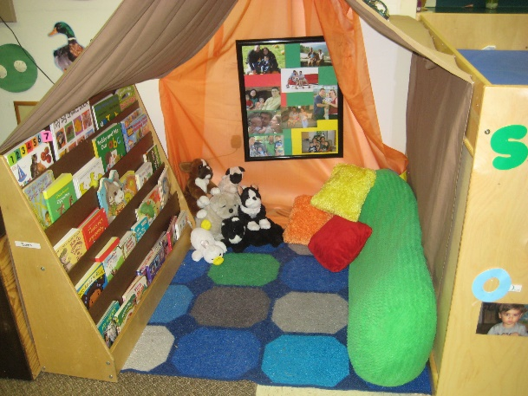

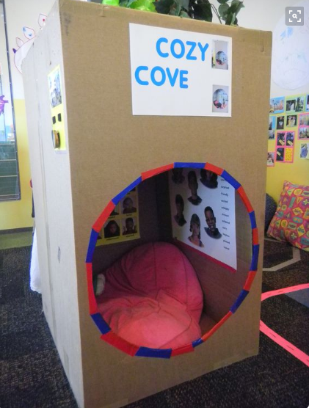

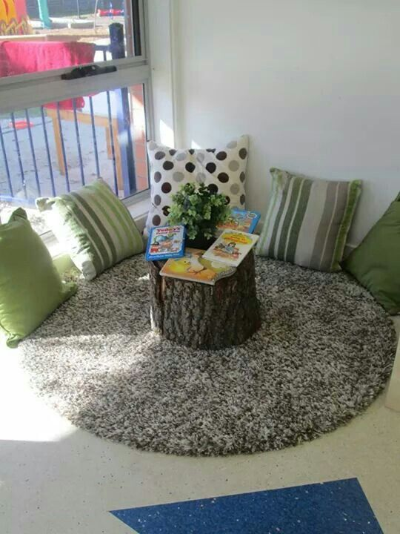
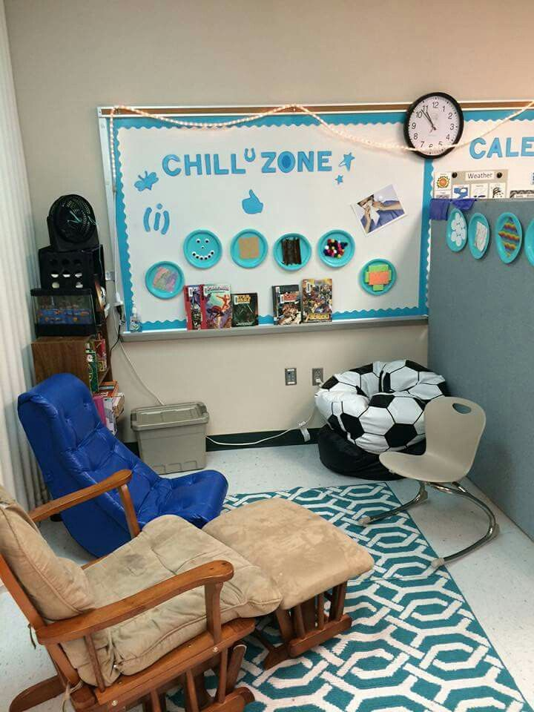
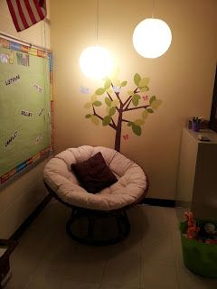

Tool Kit Ideas

Kaleoscope
Stress balls
Lavender/vanilla smells – i.e. add 3 drops of essential oil to playdough recipes
I spy stick (Wondertube) or I spy books
High interest books with pictures (i.e. dinosaurs, animals, World Records)
Gum
Massager
Noise reducing headphones
Stuffy
Worry rocks
Weighted items (i.e. lap pad, shoulder pad)

Idea Cards
Count to 50
Hum a song
Imagine your safe place
Draw a picture
Take deep breaths

